Vrushali Panthagadi

Dahisar East, Mumbai-68
Contact: +91-9029431911; Email: vrushalikpan@gmail.com

Electrical Engineer Professional

SKILLS  Leadership  Strong interpersonal skills  Strong Analytical skills  Reporting & Documentation  Technical/Quality Support  Good Communication Skills | - Sincere & diligent professional with wide experience in Electrical panels manufacturing, estimation, electrical designing, data center cooling feasibility, data center electrical designing, power set-up high side infra designing.  - Thorough understanding of Production, Client handling & Electrical Design.  - Deft in co-coordinating and working with cross-functional teams ensuring optimal utilization of resources leading to overall profitability with all levels of management.  - Solid professional standards; excellent track record of dependability; maintain focus on achieving results while formulating and implementing solutions to meet diversity of needs

EDUCATION

Degree | Year | Institute / University | Percentage
B.E Electrical Engineering (Mumbai University) | 2010-2014 | Viva Institute of Technology (Mumbai) | 68.3%
12th (Maharashtra Board) | 2008-2009 | Vidyanidhi Kamla Raheja College (Mumbai) | 62.80%
10th (Maharashtra Board) | 2006-2007 | V.P.M’s Vidya Mandir (Mumbai) | 81.69%

PROFESSIONAL EXPERIENCE

B.E.S.T (Brihanmumbai electrical supply & transport) june 2013 (1 month)



Trainee Engineer – Mumbai

- Underground cable Fault detection in case of power Cut
- Power Layout Study and Power Distribution of Mumbai South Zone
- Training provided in various departments like Erection, Metering, Operation, Maintenance
- Power Panel working at Generation and Distribution Centre

zenith engineering corporation july 2014- feb 2015 (7 months)


Production/Estimation Engineer – Mumbai

- Handled Production of Electrical Motor Control Centre, Power Control Centre, Distribution Boards & Automatic Transfer Switch Control Panels
- Testing and Inspection Of Electrical Power Panels with the Client
- Estimation and costing of Power Panel Projects
- Handling of Clients for Project price negotiation and sales handling

TATA COMMUNICATIONS juNE 2015- PRESENT

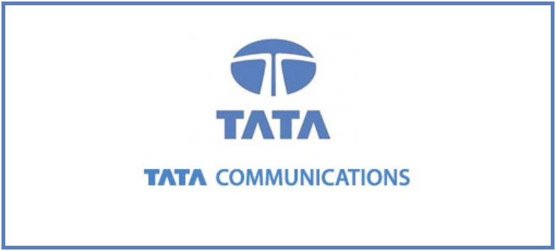

Customer Service Executive (Design Engineer) (Facilities & Infrastructure Management) – Mumbai

- Project co-ordinator for Mumbai Datacentre Projects. Includes tracking indents, PR Status, PO releases for PAN India Projects.
- Preparing BOQ of all Datacentre electrical equipment & materials like Electrical Panels, PDU, UPS, Battery Banks, Bus ducts, Cable Schedule, STS etc.
- Preparing Electrical SLDs for datacentres.
- Handling High HT side Electrical SLDs for PAN India Tata Communications Projects.
- Simulation of CFD (Computational fluid dynamics) for Cooling feasibility of Datacentre using TileFlow Software.
- Preparing Scope of work, technical specifications, quality, Factory acceptance test, Site acceptance test, etc. check-list.
- Attending Factory Acceptance Tests for all electrical equipment like Transformers, Electrical control panels, STS, PDU, UPS, etc.
- Supervising Site Acceptance Tests for electrical equipment of data center.
- Supervising final Integrated System testing during the final stage of project.
- Meeting new vendors & technically evaluating them for their product efficiency & their team’s ability to contribute in driving the project smoothly.

ACADEMIC RESEARCH PROJECTS

Project Title: Enhanced Power Quality Improvement using Hybrid Active Power Filter

- Deals with the elimination of the current harmonics from the system
- Essential mainly where non-linear loads and Power Electronic Devices are used
- Hybrid Filter consisted of combination of both Passive and Active Power Filter
- Hybrid combination of both reduced the rating of the Filters used and increased the efficiency of the system in terms of power quality

Extra-Curricular Certificates/Activities:

- Organizer and anchor of Singing Competition, Hitaishi fest 2013
- Organizer of Antakshari Competition, Hitaishi fest 2013
- Finalist of Singing Competition, Hitaishi fest 2014
- Finalist of Dance Competition, Hitaishi fest 2014

Other Activities:
Industrial Visit at Reliance Power Plant, Dahanu
Industrial Visit at Tarapur Atomic Power Station, Tarapur
Industrial Visit at Padghe H.V.D.C Substation

Languages: English, Hindi, Marathi

